DATA FILE LAYOUT
Data files: San Francisco Bay Area household, person, and trip data files
Last update: May 29, 2004 by Laurie G.

The following files are part of the San Francisco Bay Area “SF MTC” trip files. Each record is defined next to the file.

(1) MTC_HHData.* 9,359 households
(2) MTC_PersonData.* 21,278 people
(3) MTC_TripData.* 62,092 trips

MTC_HHData file layout
NAME VARIABLE DEFINITION
id Household identification number
county County of residence, FIPS number
sd Superdistrict of residence (see picture in this document)
travday First? travel day 1=Mon, 2=Tues, 3=Wed, 4=Thurs, 5=Fri
travdate Travel date in myy format NOTE: SOME BAD FIELDS
autos Number of automobiles
trucks Number of trucks
mcycles Number of motorcycles
mopeds Number of mopeds
bikes Number of bikes
hhsize Number of persons in HH
hhsize5 Number of persons ages 5 or older in HH
building Type of building code; 1=single family; 2=duplex; 3=apartment; 4=condo/townhouse; 5=mobile home; 6=hotel/motel; 7=group quarter
yrshome Number of years at current residence
tenure2 Imputed tenure; 1=owner; 2=renter; 3=unknown
income2 Imputed HH income;
1 = <$5,000 8 = $35,000 - 39,999 15 = >= $125,000
2 = $5,000 - 9,999 9 = $40,000 - 44,999 88 = Unknown
3 = $10,000 - 14,999 10 = $45,000 - 49,999 99 = Refused
4 = $15,000 - 19,999 11 = $50,000 - 59,999
5 = $20,000 - 24,999 12 = $60,000 - 74,999
6 = $25,000 - 29,999 13 = $75,000 - 99,999
7 = $30,000 - 34,999 14 = $100,000-124,999

inc_000 HH income (1000’s $)
Filter_$ yrshome >= 0

MTC_PersonData file layout
id Household identification number
person Person identification number
relat2 Relationship code
1 = wife/husband 9 = unmarried partner
2 = son/daughter 10 = roommate/friend
3 = stepdaughter/stepson 11 = boarder/lodger
4 = sister/brother 12 = employee
5 = mother/father 13 = visitor
6 = grandchild 14 = other non-relative
7 = other relative 15 = unknown
8 = foster child
sex Gender (1=male; 2=female)
age Age in years
agecode Age groupings
1 = <5 6 = 46-55
2 = 6-15 7 = 56-65
3 = 16-25 8 = 66-75
4 = 26-35 9 = >75
5 = 36-45
license Driver’s license indicator (1=yes; 0=no)
ethnic Ethnicity code
0 = White 5 = Chinese
1 = Black 6 = Japanese
2 = Hispanic, Mexican 7 = Vietnamese
3 = Hispanic, other 8 = Filipino
4 = Native American 9 = Other Asian
employed Employment status code
1 = Employed full-time 5 = Student part-time
2 = Employed part-time 6 = Unemployed, looking
3 = Retired 9 = Other
4 = Student full-time
occuptn Occupation code
1 = Executive/admin/manager
2 = Professional spec
3 = Technicians and related
4 = Sales
5 = Administrative support
6 = Private household
7 = Protective service
8 = Other service
9 = Faming/forestry/fish
10 = Precision prod, craft
11 = Machine operator/assembly
12 = Transportation and material mov.
13 = Handlers/laborers
business Business code
1 = farming, forestry, fish
2 = mining
3 = construction
4 = manufacturing
5 = transportation, communication, utilities
6 = wholesale trade
7 = retail trade
8 = finance, insurance, real estate
9 = services
10 = government, public administration
worktrct Census tract of work
workyrs Years at current work address
disable Has disability impacting transit use
walk3blk Has difficulty walking more than 3 blocks
boardbus Has difficulty boarding bus
ridebus Has difficulty riding in bus
ridetaxi Has difficulty riding in taxi
othrdiff Other difficulties related to transit use
county County of residence; FIPS code
homesd Residence Superdistrict
workcnty Work County code
worksd Work Superdistrict code
empres Employed residence; 0=no; 1=yes

MTC_TripData file layout
county County of residence; FIPS code
id Household identification number
travday First? travel day 1=Mon, 2=Tues, 3=Wed, 4=Thurs, 5=Fri
person Person identification number
tripno Trip number
otract Census tract of trip origin
dtract Census tract of trip destination
mode Mode of travel
1 = auto driver 13 = dial-a-ride passenger
2 = auto passenger 14 = BART passenger
3 = truck driver 15 = CalTrain passenger
4 = truck passenger 16 = Amtrack passenger
5 = van driver 17 = Airplane passenger
6 = van passenger 18 = Ferry passenger
7 = taxi/limo passenger 19 = Motorcycle driver
8 = public bus passenger 20 = Motorcycle passenger
9 = school bus passenger 21 = Moped
10 = cable car passenger 22 = Bicycle
11 = street car passenger 23 = Walk
12 = shuttle bus passenger 24 = Other
opurp Type of activity at home location
1 = Home 9 = Grocery shopping
2 = Work 10 = Non-food shopping
3 = Work-related 11 = Education
4 = Personal business 12 = Child care
5 = Medical/dental 13 = Serve adult passenger
6 = Visiting 14 = Serve child passenger
7 = Eat meal 15 = Change travel mode
8 = Recreation 16 = Other
dpurp Type of activity at destination location
See above (opurp) for labels.
otime Departure time at origin (HHMM)
dtime Arrival time at destination (HHMM)
vocc Number of people in vehicle
prearr Indicates if prearranged carpool
parktype Type of parking facility made
1 = On street, free 6 = Service/repair
2 = On street, pay 7 = Resident parking
3 = Employee lot/garage 8 = Cruising
4 = Lot/garage, free 9 = Not parked
5 = Lot/garage, pay
parkcost Parking cost (cents)
parkunit Frequency of payment for parking
1 = per day 5 = semi-annual
2 = per week 6 = per year
3 = per month 9 = other
4 = quarterly
bridge1 First bridge crossed during trip
1 = SF/Oakland 8 = Richmond/San Rafael
2 = Golden Gate 9 = Unknown
3 = San Mateo/Hayward 10 = High Street
4 = Dumbarton 11 = Fruitvale
5 = Carquinex 12 = Bay Farm Island
6 = Antioch 13 = Park Street
7 = Benicia/Martinez
bridge2 Second bridge crossed during trip
See above for labels.
tranoper Transit operating company (see SPSS labels for detail; 34 agencies represented)
farepaid Fare paid ~ NOTE: NOT CLEAR WHAT THIS IS; Appears to have missing data and is primarily associated with bus users.

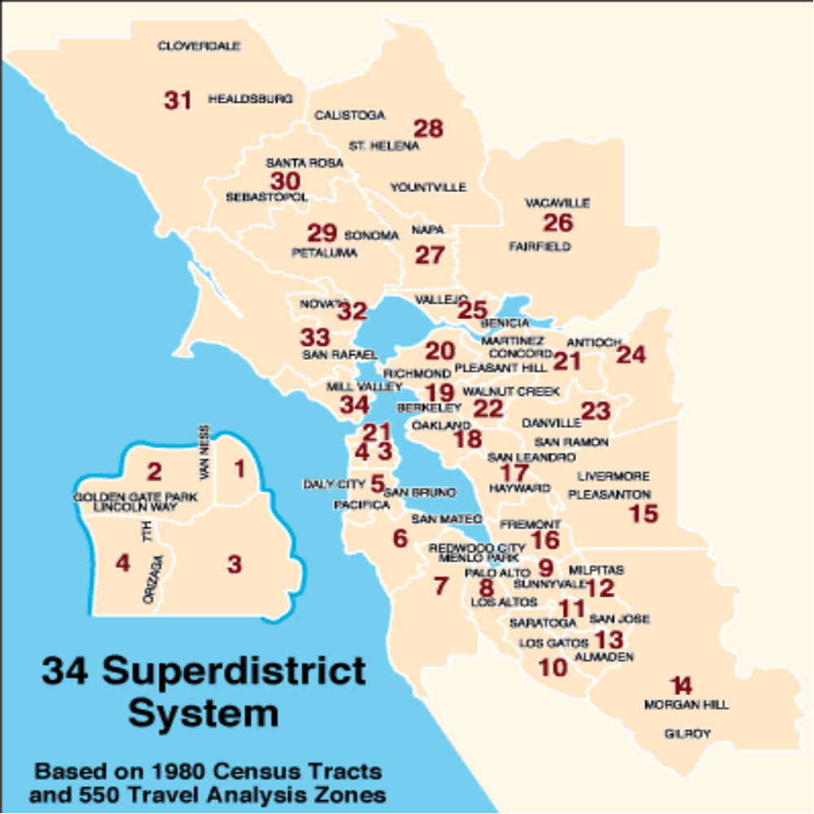

Correspondence Between MTC 34 Superdistricts and MTC 1099 TAZ

Superdistrict Number and Area |  | Range of  1099 in SD | Number of  TAZ in SD
1 | Greater Downtown San Francisco | 1 - 31 | 31
2 | Richmond District | 32 - 65 | 34
3 | Mission District | 66 - 109 | 44
4 | Sunset District | 110 - 127 | 18
5 | Daly City/San Bruno | 128 - 172 | 45
6 | San Mateo/Foster City | 173 - 208 | 36
7 | Redwood City/Menlo Park | 209 - 242 | 34
8 | Palo Alto/Los Altos | 243 - 274 | 32
9 | Sunnyvale/Mountain View | 275 - 331 | 57
10 | Saratoga/Los Gatos | 332 - 378 | 47
11 | Central San Jose | 379 - 422 | 44
12 | Milpitas/East San Jose | 423 - 468 | 46
13 | South San Jose | 469 - 499 | 31
14 | Gilroy/Morgan Hill | 500 - 511 | 12
15 | Livermore/Pleasanton/Dublin | 512 - 535 | 24
16 | Fremont/Union City | 536 - 581 | 46
17 | Hayward/San Leandro | 582 - 637 | 56
18 | Oakland/Alameda | 638 - 716 | 79
19 | Berkeley/Albany | 717 - 747 | 31
20 | Richmond/El Cerrito | 748 - 789 | 42
21 | Concord/Martinez | 790 - 826 | 37
22 | Walnut Creek/Lamorinda | 827 - 851 | 25
23 | Danville/San Ramon | 852 - 867 | 16
24 | Pittsburg/Antioch/Brentwood | 868 - 901 | 34
25 | Vallejo/Benicia | 902 - 931 | 30
26 | Fairfield/Vacaville/Dixon | 932 - 970 | 39
27 | Napa/American Canyon | 971 - 981 | 11
28 | Saint Helena/Calistoga | 982 - 990 | 9
29 | Petaluma/Sonoma/Cotati | 991 - 1011 | 21
30 | Santa Rosa/Sebastapol | 1012 - 1040 | 29
31 | Healdsburg/Cloverdale | 1041 - 1048 | 8
32 | Novato | 1049 - 1059 | 11
33 | San Rafael/San Anselmo/Olema | 1060 - 1081 | 22
34 | Sausalito/Larkspur/Tiburon | 1082 - 1099 | 18
35 | External Boundaries | 1100 - 1120 | 21

